Bài tập tuần 8

Nhóm Oh bug!

Link sơ đồ: <https://drive.google.com/file/d/1bXBVkSiapdlvnLZtM-dBzRAo2vv5_YBf/view?usp=sharing>

BT1:

Sơ đồ:

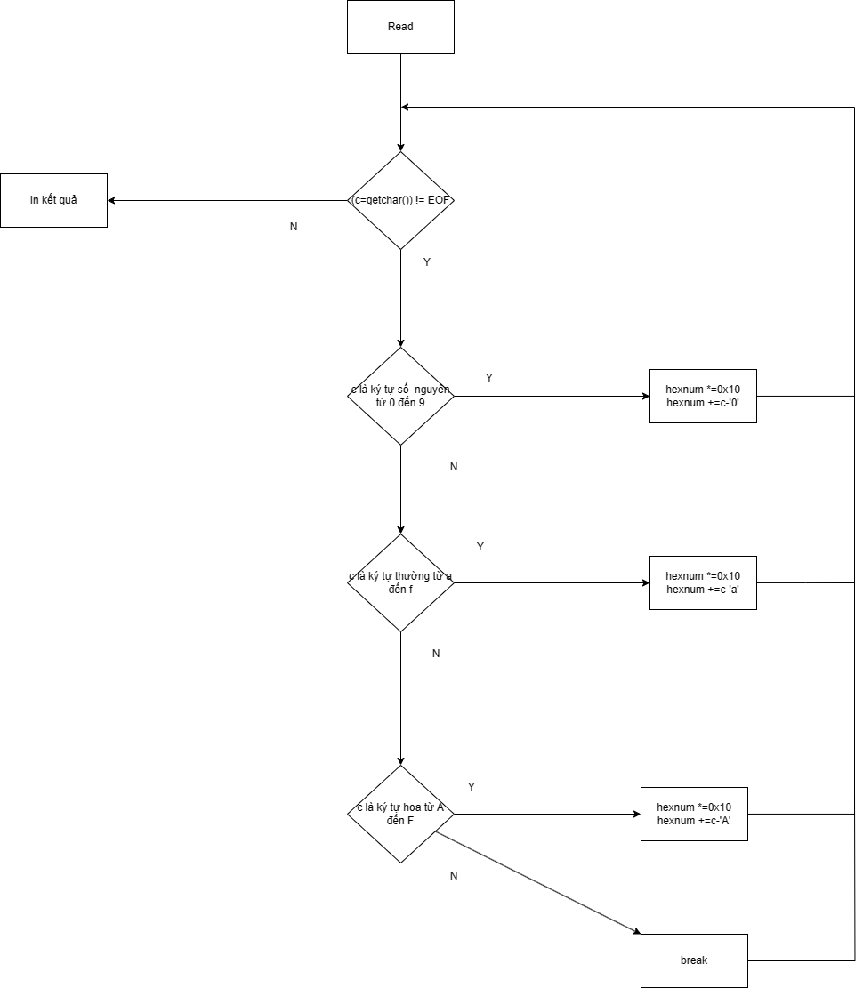

Minimum tests to archive:

Statement coverage:1 (‘1*aB’)

Branch coverage: 2 (‘’, ‘0à9,aàe, AàE, *’)

Condition coverage:

Path coverage: 1 (‘0à9,aàe, AàE, *’)

Số lượng:

Số state: 20

Số Branch: 25

Số condition: 4 (1 white, 3 switch-case) ?

Số Path: 24

Độ phủ test case:

|  |  |  |  |  |
| --- | --- | --- | --- | --- |
| Test case | Statement coverage | Branch coverage | Condition coverage | Path coverage |
| ‘059’ | 12/20 | 4/25 |  | 3/24 |
| ‘ace’ | 12/20 | 4/25 |  | 3/24 |
| ‘ACD’ | 12/20 | 4/25 |  | 3/24 |

BT2:

Table of price

Def: 3, 6, 12, 16, 19

Use: 12, 16, 17, 19, 23

|  |  |  |
| --- | --- | --- |
| Pair ID | Def | Use |
| 1 | 3 | 12 |
| 2 | 3 | 16 |
| 3 | 3 | 17 |
| 4 | 3 | 19 |
| 5 | 3 | 23 |
| … | … | … |
| 5x5=25 |  |  |

Table of Use

Def: 1

Use: 4, 8, 10, 12, 16

|  |  |  |
| --- | --- | --- |
| Pair ID | Def | Use |
| 1 | 1 | 4 |
| 2 | 1 | 8 |
| 3 | 1 | 10 |
| 4 | 1 | 12 |
| 5 | 1 | 16 |